Phase2 Week3 Assignment

Prompt Template & JSON Schema Manager

Module: Digital dietician
User Story ID: HC-122
User Story Title: Share Diet chart with Patients via email

User Story Description:
As a diagnostic technician, I want to automatically send patients their diet chart securely through email once patient reports are validated.

Acceptance Criteria:
1. Diet must be sent only after validation by Dietician
2. Email must include secure download link with expiration (24 hours)
3. System must log all report delivery attempts
4. Support for PDF format with encryption
5. Handle failure scenarios (invalid email id, service down)

Other searches:
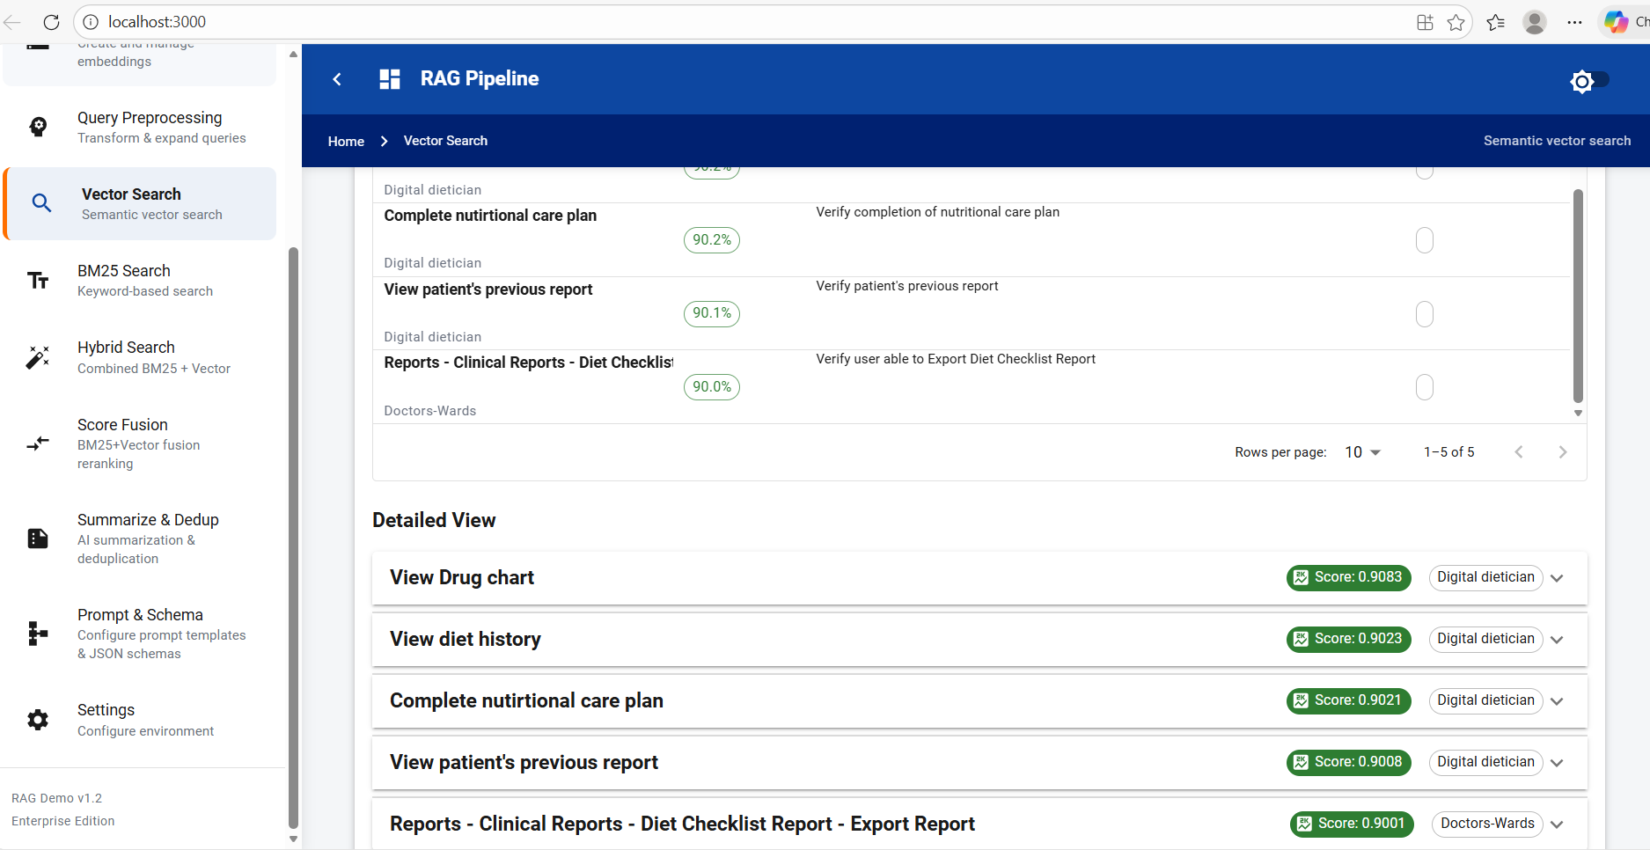

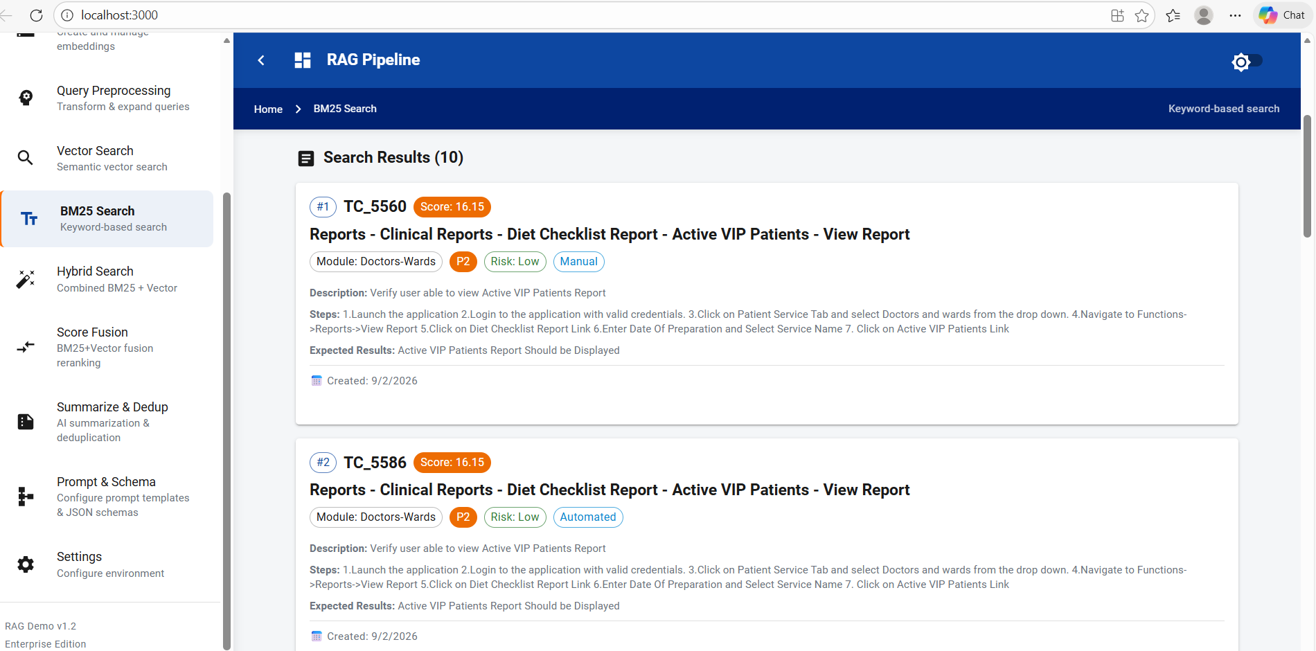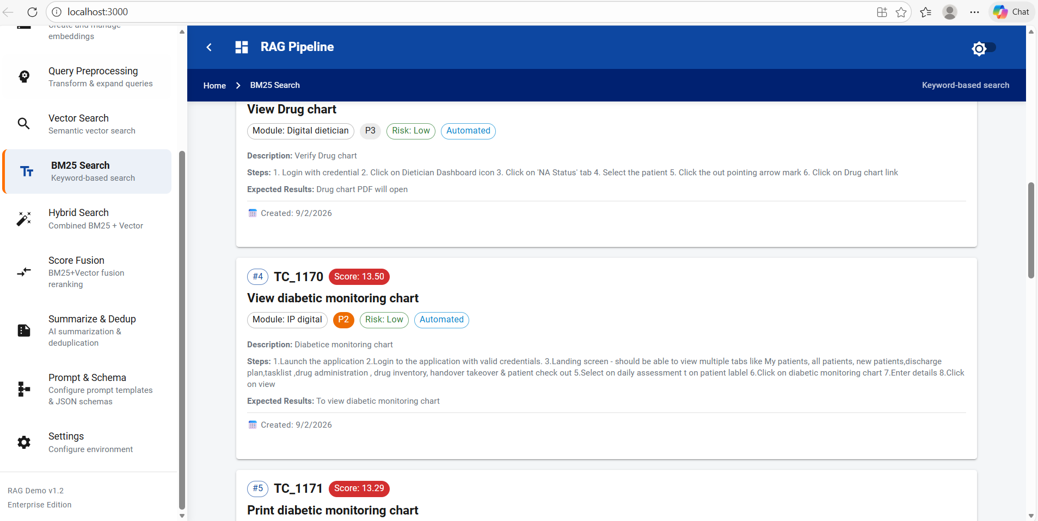

Hybrid search:
#4
TC_1052
Hybrid: 81.7%
Found in: both
View diet history
Module: Digital dietician
P3
Risk: Low
Automated
Description: Verify Diet history
Steps: 1. Login with credential 2. Click on Dietician Dashboard icon 3. Click on 'NA Status' tab 4. Select the patient 5. Click on Diet History option
Expected Results: Diet history PDF will open

Score Breakdown:
🔤 BM25: 73.1% (raw: 11.80)🧠 Vector: 90.2% (raw: 0.90)⚖️ Hybrid: 81.7%
📅 Created: 9/2/2026
#5
TC_4355
Hybrid: 79.1%
Found in: both
Doctor Activities - Raise Request - Diet
Module: Wards-Doctors
P4
Risk: Low
Automated
Description: Verify user able to Raise Diet Request
Steps: 1. Launch the application. 2. Login to the application with valid credentials 3.Click on Patient Service Tab and select Doctors and wards from the drop down. 4.Navigate to Functions->Transactions->Wards Dashboard 5.Select the Ward 6. Right Click on Patient IP Number and Navigate to Doctor Activities - > Raise Request. 7. Select Diet Tab 8. Click on Initiate and click ok on the pop up displayed. 9. Select Diet Restriction, Diet Consistency and Meal Type 10. Click on Release and Click ok on the pop up displayed
Expected Results: The Diet Request Should be Initiated. Diet Request Number should be Generated Successfully.

Score Breakdown:
🔤 BM25: 68.7% (raw: 11.09)🧠 Vector: 89.6% (raw: 0.90)⚖️ Hybrid: 79.1%
📅 Created: 9/2/2026
#6
TC_2885
Hybrid: 79.1%
Found in: both
Doctor Activities - Raise Request - Diet
Module: Emergency
P1
Risk: Critical
Automated
Description: Verify user able to Raise Diet Request
Steps: 1.Launch the Application. 2.Login to the application with valid credentials 3.Click on Patient Service Tab and select Emergency from the drop down. 4.Navigate to Functions-> Transactions-> Dashboard 5.Click on Emergency Worklist Tab 6. Right Click on Patient EP Number and Navigate to Doctor Activities - > Raise Request. 7. Select Diet Tab 8. Click on Initiate and click ok on the pop up displayed. 9. Select Diet Restriction, Diet Consistency and Meal Type 10. Click on Release and Click ok on the pop up displayed
Expected Results: The Diet Request Should be Initiated. Diet Request Number should be Generated Successfully.

Score Breakdown:
🔤 BM25: 68.7% (raw: 11.09)🧠 Vector: 89.5% (raw: 0.90)⚖️ Hybrid: 79.1%
📅 Created: 9/2/2026
#7
TC_3040
Hybrid: 79.1%
Found in: both
Nurse Activities - Raise Request - Diet
Module: Emergency
P1
Risk: Critical
Automated
Description: Verify user able to Raise Diet Request
Steps: 1.Launch the Application. 2.Login to the application with valid credentials 3.Click on Patient Service Tab and select Emergency from the drop down. 4.Navigate to Functions-> Transactions-> Dashboard 5.Click on Emergency Worklist Tab 6. Right Click on Patient EP Number and Navigate to Nurse Activities - > Raise Request. 7. Select Diet Tab 8. Click on Initiate and click ok on the pop up displayed. 9. Select Diet Restriction, Diet Consistency and Meal Type 10. Click on Release and Click ok on the pop up displayed
Expected Results: The Diet Request Should be Initiated. Diet Request Number should be Generated Successfully.

Score Breakdown:
🔤 BM25: 68.7% (raw: 11.09)🧠 Vector: 89.5% (raw: 0.90)⚖️ Hybrid: 79.1%
📅 Created: 9/2/2026
#8
TC_4619
Hybrid: 78.7%
Found in: both
Daycare - Nurse Activities - Raise Request - Diet
Module: Doctors-Wards
P4
Risk: Low
Manual
Description: Verify user able to Raise Diet Request
Steps: 1. Launch the application. 2. Login to the application with valid credentials 3.Click on Patient Service Tab and select Doctors and wards from the drop down. 4.Navigate to Functions->Daycare->Dashboard 5.Select the Ward 6. Right Click on Patient IP Number and Navigate to Nurse Activities - > Raise Request. 7. Select Diet Tab 8. Click on Initiate and click ok on the pop up displayed. 9. Select Diet Restriction, Diet Consistency and Meal Type 10. Click on Release and Click ok on the pop up displayed
Expected Results: The Diet Request Should be Initiated. Diet Request Number should be Generated Successfully.

Score Breakdown:
🔤 BM25: 67.7% (raw: 10.94)🧠 Vector: 89.7% (raw: 0.90)⚖️ Hybrid: 78.7%
📅 Created: 9/2/2026
#9
TC_4950
Hybrid: 78.2%
Found in: both
Wards Dashboard - Nurse Activities - Raise Request - Diet
Module: Doctors-Wards
P3
Risk: Low
Automated
Description: Verify user able to Raise Diet Request
Steps: 1. Launch the application. 2. Login to the application with valid credentials 3.Click on Patient Service Tab and select Doctors and wards from the drop down. 4.Navigate to Functions->Transactions->Wards Dashboard 5.Select the Ward 6. Right Click on Patient IP Number and Navigate to Nurse Activities - > Raise Request. 7. Select Diet Tab 8. Click on Initiate and click ok on the pop up displayed. 9. Select Diet Restriction, Diet Consistency and Meal Type 10. Click on Release and Click ok on the pop up displayed
Expected Results: The Diet Request Should be Initiated. Diet Request Number should be Generated Successfully.

Score Breakdown:
🔤 BM25: 66.9% (raw: 10.80)🧠 Vector: 89.5% (raw: 0.90)⚖️ Hybrid: 78.2%
📅 Created: 9/2/2026
#10
TC_5560
Hybrid: 50.0%
Found in: bm25
Reports - Clinical Reports - Diet Checklist Report - Active VIP Patients - View Report
Module: Doctors-Wards
P2
Risk: Low
Manual
Description: Verify user able to view Active VIP Patients Report
Steps: 1.Launch the application 2.Login to the application with valid credentials. 3.Click on Patient Service Tab and select Doctors and wards from the drop down. 4.Navigate to Functions->Reports->View Report 5.Click on Diet Checklist Report Link 6.Enter Date Of Preparation and Select Service Name 7. Click on Active VIP Patients Link
Expected Results: Active VIP Patients Report Should be Displayed

Score Breakdown:
🔤 BM25: 100.0% (raw: 16.15)🧠 Vector: 0.0% (raw: 0.00)⚖️ Hybrid: 50.0%
📅 Created: 9/2/2026

